Working with C and C++

Hello friends , Let us begin our journey of programming with C and C++ languages.

C language is a bery powerful tool to learn programmning. Let us understand the working of C and C++ languages and how we can use our logical abilitites to make awesome programs in C and C++.

Before we delve deeper into the C++ programming language let us understnd some basic fundamentals of a computer to get a deep insight on what we shall be covering in this tutorial.

What is a computer?

A computer is an electronic device that is used to perform mathematical computations

Such as addition,multiplication division and subtraction according to the user needs. Although today computers are mostly electronic some of the computing devices used previously were not electronic. Example see the abacus:-

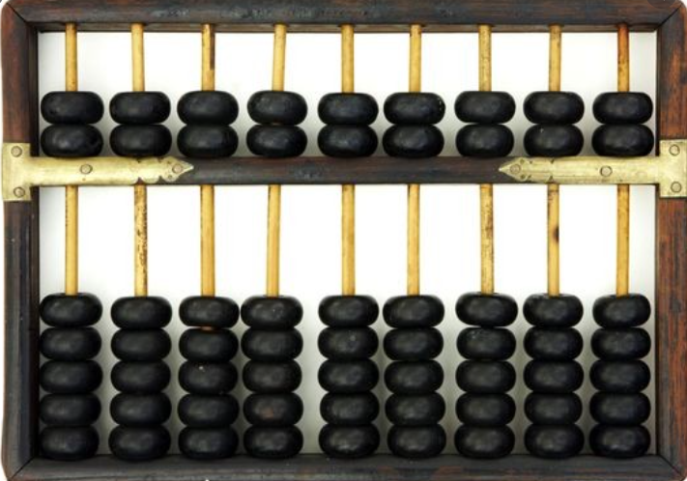

Is the worlds first mechanical computer and it is not electronic.

Let us now understand what parts a computer system has.:-

A computer system s composed of two entities called as hardwre and software.

Hardware refers to the tangible portions of a computer system. The portions that we can touch and see. The parts that sum together to make up a computer is called a hardware. Software on the other hand is composed of the intangible portions of the computer system and is about the things that we can feel but not touch.

What are computer peripherals?

Computer peripherals are the external devices attached to the computer system and are mainly classified into two types:-

Input Devices :- Input devices are those devices that are used to give input to a computer system. Eg. Mouse and Keyboard.

Output Devices:- Outpt Devices are those devices that are used to obtain output ie result of a computation. Eg Monitor Speaker etc

Why use the word computation?

Guys you all might be thinking that why we are using the word Computation repeatedly. We see computers play music,movies and games, store files, surf the web and do many things on an application basis but aren’t we taking about it. Our definition of compute, on the other hand , does not talk about these use cases of a computer system. Instead it sees computer as a device that performs mere computation. So is a computer system system similar to a calculator? Let us understand this!

Computer as a calculator

Computer system can be seen as a calculator. Theoretically it should be seen only as a calculator, because behind every action a computer performs like playing game, movie or song, surfing the net etc. there is some form of a mathematical computation going on. At this point of time you must both fascinated and confused as to how using basic mathematics could I achieve such an immersive experience inside a computer. To understand this we must first understand how data is stored inside a computer system..

We store data inside a computer system with the help of a logic circuit called as flipflop. But to understand basic flip flops we first need to understand basic Logic gates and boolean algebra which would be beyond the scope of this blog.

So what is inside scope?

Computer is able to understand the

We can now understand in which form is data stored inside a computer system.

In a computer system the data is stored in hard disk and Ram. Hard Disk stores data in the form of North Pole and South Pole in magnetic tape while data in a RAM is stored in the form of positive and negative charge in a capacitor. Hard disk is a permanant source of information storage whereas ram stores data in temporary form.

Now let us understand the concept of programming.

What is programming?

Programming is writing code that makes the computer work in a deterministic manner according to the users will.

How can we write our own programs?

Programs can be written by literally anyone. But before writing a good program we need to develop an algorithm to understand to develop a strong logic for the program. This blog aims to foster new thinking paradigms in your brain so that you can develop good algorithms and eventaully good programs.

Let us understand what an algorithm is.

What is an algorithm?

An algorithm is a sequence of finite steps that solve a particular computational problem. An algorithm is written for the purpose of understanding by the user and can be written in any human understandable language.

Let us understand algorithm with the help of a simple problem:-

Consider the problem of eating an apple.

The algorithm required to solve the problem can be written as:-

START

Step 1)Buy an apple from the market

Step 2) Cut the apple into pieces

Step 3) Add salt

Step 4) Serve